**Cerner to Bridge ORU Requirements**

**Version 1.2**

**Prepared By: Levy Lazarre and Hope Kaczmarczyk**

**Date: 7/29/2019**

Document Control 3

Resources 3

Document Version Control 3

1. Introduction 4

1.1 Purpose 4

1.2 Project Scope 4

1.3 Terminology Standards 4

1.3.1 Acronyms 4

1.3.2 Glossary 4

1.4 Document References 4

2. Diagrams 5

3. Requirements 7

3.1 Functional Requirements 7

3.2 Messaging Protocols 9

3.2.1 Inbound to the BayCare Cloverleaf From Cerner 9

3.2.2 Outbound from BayCare CloverLeaf 9

4. HL7 Messaging 10

4.1 Messaging Format 10

4.1.1 Segments 10

4.1*.*2 Messaging Event Types 10

4.1*.*3 Cloverleaf Configuration Files 11

4.1.4 Cloverleaf Site Location 11

4.2 Data Transformation Requirements 11

4.3 Sample Message 15

Appendix A: Risks and Concerns 18

Appendix B: Issues List 18

# **Document Control**

## Resources

|  |  |  |
| --- | --- | --- |
| **Name** | **Role** | **Email** |
| Michael J King | IS Project Manager, BayCare | Michael.King@baycare.org |
| Andrew Miller | System Engineer,  Consulting Advancement Team, Cerner | Andrew.Miller@cerner.com |
| Matthew Awosanya | Technology Consultant, Cerner | matthew.awosanya@cerner.com |
| Michael Harris | Software Engineer, Cerner | Michael.Harris@Cerner.com |
| Nicole Gitney | Director of Nursing Informatics | Nicole.Gitney@baycare.org |
| Debra Armstrong | SR Systems Analyst,  APPS - DOCUMENTATION | Debra.Armstrong@baycare.org |
| Hope Kaczmarczyk | SR Integration Analyst, BayCare EIT | Hope.Kaczmarczyk@baycare.org |
| Levy Lazarre | Integration Analyst, Baycare EIT | Levy.Lazarre@baycare.org |
| Amy S Knight | SR Systems Analyst,  APPLICATIONS ANCILLARY | Amy.Knight@baycare.org |
| Jeff Jung | BayCare Manager Laboratory IT | [Jeffrey.Jung@BayCare.org](mailto:Jeffrey.Jung@baycare.org) |
| Jane K Holz | SR Systems Analyst,  LAB COMPUTER | Jane.Holz@baycare.org |
| Danielle Sawyer | Systems Analyst,  REVENUE CYCLE APPLICATIONS | Danielle.Sawyer@baycare.org |

## Document Version Control

|  |  |  |  |
| --- | --- | --- | --- |
| **Version** | **Date** | **Modifier** | **Description** |
| V1.0 | 01/04/2018 | Levy Lazarre | Original document |
| V1.1 | 01/12/2018 | Hope Kaczmarczyk | Added Cerner information and project diagrams |
| V1.2 | 07/29/2019 | Yitzhak Magoon | Updated document for Cerner Model |
|  |  |  |  |

# 1. Introduction

## 1.1 Purpose

The purpose of this document is to describe the **ORU** (Results) Interface going from Cerner Millennium to Cerner Bridge Solutions.

Bridge is a Cerner application used by nurses for the management and documentation of breast milk/infant feeding to newborns and blood transfusions to hospital patients. Limited Laboratory results are sent from BayCare Cerner Millennium to Bridge for viewing purposes only to help with blood product transfusions.

## 1.2 Project Scope

The scope of this project is to automate the integration of the Cerner Bridge Solutions application with the Soarian HIS via HL7 ADT interface and the Cerner EMR via HL7 Orders, Results, and BTS interfaces. The current document describes the ORU interface, unsolicited Laboratory results from Cerner Millennium to Bridge.

## 1.3 Terminology Standards

### 1.3.1 Acronyms

**ADT** – Admission, Discharge, Transfer: mainly demographic and patient location data

**BTS -** Blood Product Transfusion Status/Disposition

**DTA** - Discrete Task Assay; reference data item

**HIS** – Health Information System, the source and keeper of patient demographic data

**ORU** – A HL7 Observation Result message

### 1.3.2 Glossary

**ADT Event** – Trigger event associated with a patient event: registration, admission, discharge, transfer, update…

**Alias** - An identifier used to represent an item, such as a location, order, specimen type, or result.

**Bridge** - An external Cerner Solution used by Baycare for Medical Breast Milk/Infant Feeding Management and

Transfusion Administration.

**Contributor System –** External System that sends to and/or receives data from Cerner Millennium. A “Contributor System” is built on Cerner as part of an interface or data feed.

**Contributor Source –** A source created on Cerner used to identify inbound and/or outbound aliases for data sent to and received from Foreign Systems.

**Scripting –** Custom Cerner programs written to modify, format, and filter message transactions for the interfaces. The types of scripts used by FSI are Suppression, Route, Modify Object, Modify Original, Type, and ACK.

## 1.4 Document References

1. Cerner Bridge Solutions Interface Specifications.doc– Cerner July 1, 2016

2. BM AND BMM TESTING PATIENTS.xlsx

3. Cerner HL7 Specifications: Unit 10o - Result and Document Processing Outbound – Cerner Dec. 4, 2017

# 2. Diagrams

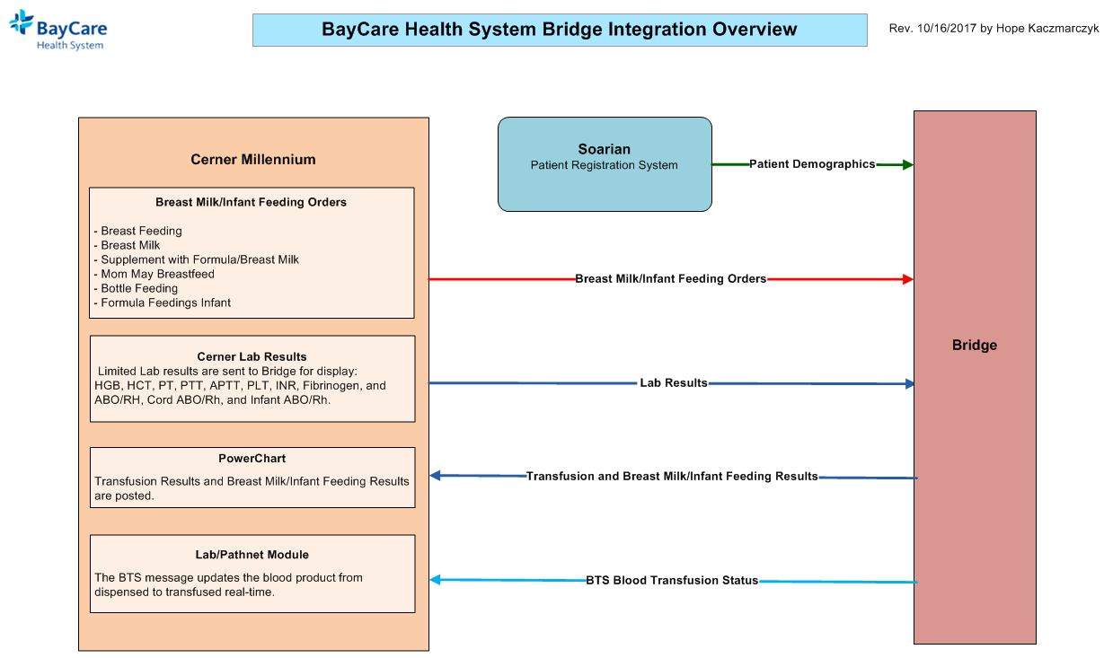

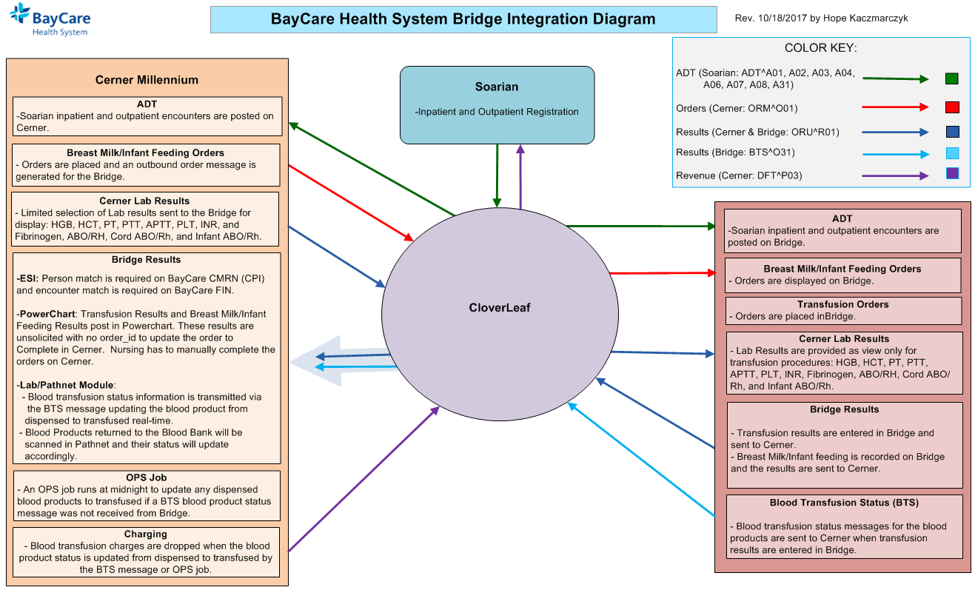

CloverLeaf Threads for BayCare Cerner Lab Results outbound to Bridge on CloverLeaf Site: cerner_results_7_p

# 3. Requirements

## 3.1 Functional Requirements

|  |  |  |
| --- | --- | --- |
| **Cloverleaf** |  |  |
| **Number** | **Requirement Name** | **Requirement Description** |
| FR.2018.1.0 | Filter results to send only hospital patients. | A TCL advanced HL7 filter is used to limit the results sent to Bridge to only those for BayCare hospitals patients. |
|  |  |  |
| FR.2018.2.0 | Send the BayCare CPI in PID.2 | The BayCare CPI will be sent in PID.2, with an identifier type hardcoded to “CMRN”. |
| FR.2018.3.0 | Send the BayCare MRN in PID.3 | Only one identifier (MRN) may be sent in PID.3; the identifier type will be hardcoded as “MRN” |
| FR2018.4.0 | Send the account number in  PID.18 | The account (FIN) number is sent in PID.18; the identifier type will be hardcoded as “FIN”. |

|  |  |  |
| --- | --- | --- |
| **Cerner** |  |  |
| **Number** | **Requirement Name** | **Requirement Description** |
| FR.2019.07.29.1 | New Cerner Contributor Source: **Invision** | The contributor system used to be Bridge, but with the model upgrade it was replaced with Invision.Aliases for each DTA/event code being sent to Bridge were already aliased on Invision, so all of the aliases were changed in Bridge to match the Invision aliases.  All lab results with OBR.24 = “Lab” or “BB” are sent to Bridge. Bridge then filters out the lab results that they want to post.  Note: if additional results are to be added to post on Bridge. Cerner Bridge will need to be notified so they can map the results to post on Bridge. |
| FR.2018.01.1 | **ESO Interface Trigger:**  Observation Reporting/ORU Discrete Gen Lab/CE Server GLB/GRP (CQM Class: CE) | This trigger causes the BayCare Laboratory results to be processed outbound when entered in Pathnet as long as the result items are not aliased with DONOTSEND for contributor source INVISION on code set 72.  - The following segments are set to be sent outbound by this trigger:   * HL7 MSH * HL7 PID * HL7 PV1   HL7 OBR/OBX/NTE |
| FR.2018.01.2 | Global Script:  - route_out | route_out (global script): Logic to route BayCare Laboratory results to the ORU_LAB_RESULTS_OUT comserver. Logic is based on:   * Message Type = ORU, cqm_type in “AP”, “MICRO”, or “GRP” * End logic for all ORU messages outbound is sent to these comservers:   - ORU_LAB_RESULTS_OUT |
| FR.2019.07.29.2 | New scripts:  fsi_common (generic)  oru_lab_out (mod object)  fsi_add_pcpe (generic) | oru _lab_out, Mod Object script, for BayCare Laboratory  results outbound:   * Calls the fsi_common generic script to load all subroutines * Adds the correct ordering provider to OBR.16, the correct order name/description to OBR.4, and the correct order alias to OBR.3 for AP results. * Replace any primary care physician (PCP) with the PCP at the encounter level in the PD1 segment. * Deletes any DONOTSEND* result items and renumbers the OBX segments accordingly. *Note: This is a known Cerner issue where LOINC coding overrides the DONOTSEND functionality. Custom Coding was needed to fix the issue.   Filters all ORU messages if there is no OBX segment after the OBX segments are stripped as described above. |

## 3.2 Messaging Protocols

Below are listed the details for the messaging protocols that will be leveraged for this integration. Please see the reference document located on the Integration SharePoint server.

### 3.2.1 Inbound to the BayCare Cloverleaf From Cerner

* TCP MLLP Server Connection
  + HL7 2.3 ORU messages from BayCare Cerner to BayCare Cloverleaf

### 3.2.2 Outbound from BayCare CloverLeaf

* TCP MLLP Client Connection
  + HL7 2.3 ORU messages to Bridge.
  + HL7 2.3 Acknowledgment Messages returned from CloverLeaf to BayCare Cerner

# 4. HL7 Messaging

## 4.1 Messaging Format

### 4.1.1 Segments

The segments utilized for this interface are:

MSH

PID

[PD1]*

PV1*

OBR

{OBX}

[{NTE}]

*Message Construction Notes:*

*[Square Brackets] – Optional*

*{Curly Brackets} – Repeatable*

*MSH – Message Header*

*PID – Patient ID segment*

*PD1 – Additional Patient Demographics* Removed by CloverLeaf*

*PV1 – Patient Visit segment * Removed by CloverLeaf*

*OBR – Observation request segment*

*OBX – Observation/Result segment*

*NTE – Note Segment*

### 4.1*.*2 Messaging Event Types

Below are the messages types necessary for this integration

Supported ORU Events

|  |  |
| --- | --- |
| **Event Type** | **Description** |
| R01 | Discrete, Unsolicited Result Message from Cerner to Bridge |

### 4.1*.*3 Cloverleaf Configuration Files

HL7 Variants: 2.3 cerner_emr and 2.3 eicu

Xlate: cerner_bridge_oru.xlt

### 4.1.4 Cloverleaf Site Location

Production = cerner_results_7_p

Test = cerner_results_7

## 4.2 Data Transformation Requirements

| **Field Description** | **HL7 Field Loc.** | **Required R/O/C** | **Data Type** | **Length** | **Notes** |
| --- | --- | --- | --- | --- | --- |
| **Message Header Segment** | **MSH** | R |  |  | CloverLeaf: PathCopy |
| Sending Application | MSH.3 | C |  |  | Cerner sends “HNAM”.  CloverLeaf: hardcodes “BCHS_LAB” |
| Sending Facility | MSH.4 | R |  |  | Copy inbound MSH.5 |
| Receiving Application | MSH.5 | O |  |  | Hardcode “BRIDGE” |
| Receiving Facility | MSH.6 | R |  |  | Cerner sends “CERNER”.  CloverLeaf copies inbound MSH.5 to this field. |
| **Patient Identifier Segment** | **PID** | R |  |  |  |
| Patient ID (External) | PID.2 | R |  |  | CloverLeaf copy of the CMRN from PID.3 with the Identifier Type of “CMRN” |
| Patient ID (Internal) | PID.3 | R |  |  | CloverLeaf copy of the MRN from PID.3 with the Identifier Type Code of “MRN” |
| Patient Name | PID.5 | R |  |  | Copy Patient’s Last Name, First Name, Middle Name, Suffix, Name Type Code |
| Date of Birth | PID.7 | R |  |  | CloverLeaf: Copy |
| Gender | PID.8 | R |  |  | CloverLeaf: Copy |
| Race | PID.10 | O |  |  | CloverLeaf: Copy |
| Patient Account Number | PID.18 | R |  |  | CloverLeaf: Copy (first component of PID.18) with Identifier Type Code of “FIN” |
| SSN | PID.19 | O |  |  | CL to update logic  CloverLeaf: Copy |
| **Observation Request Segment** | **OBR** | R |  |  | CloverLeaf: Group ITERATE |
| Set ID - OBR | OBR.1 | RO |  |  | CloverLeaf: Copy |
| Placer Order Number | OBR.2 | RO |  |  | CloverLeaf: Copy |
| Filler Order Number | OBR.3 | O |  |  | CloverLeaf: Copy |
| Universal Service Identifier | OBR.4 | R |  |  | CloverLeaf: Copy |
| Observation Date/Time | OBR.7 | O |  |  | CloverLeaf: Copy |
| Collector Identifier | OBR.10 | O |  |  | CloverLeaf: Copy |
| Specimen Source | OBR.15 | RO |  |  | CloverLeaf: Copy the first subcomponent |
| **Observation (OBX) Segments** | **OBX** | R |  |  | **CloverLeaf: ITERATE over the group.** |
| Set ID - OBX | OBX.1 | O |  |  | CloverLeaf: Copy |
| Observation Identifier | OBX.3 | R |  |  | CloverLeaf: PathCopy |
| Procedure Result ID | OBX.3.1 | R | CE |  | This field is populated with the LOINC code assigned to the result item.  This is no longer done in Cerner – CL to update  The oru_bridge_lab_out script swaps this value with the one in OBX.3.4 which is the alias for the result item on code set 72.  If there is no LOINC code assigned to the result item, this field is a duplicate of OBX.3.4. |
| Result Description | OBX.3.2 | O | ST |  | If a LOINC code was sent in OBX.3.1, then this field is populated with the LOINC code description from the Nomenclature table.  This is no longer done in Cerner – CL to update  The oru_bridge_lab_out script swaps this value with the one in OBX.3.5 which is the display value for the result item from code set 72.  If there is no LOINC code assigned to the result item, this field is a duplicate of OBX.3.5. |
| Coding System | OBX.3.3 | O | ID |  | If a LOINC code was sent in OBX.3.1, then this field is populated with the coding system of LOINC.  This is no longer done in Cerner – CL to update  The oru_bridge_lab_out script swaps this value with the one in OBX.3.6 which is the contributor system of BRIDGE.  If there is no LOINC code assigned to the result item, this field is a duplicate of OBX.3.6. |
| Alt Procedure Result ID | OBX.3.4 | O | ID/CE |  | This field contains the LOINC code assigned to the result item or the  alias for the result item on code set 72 when there is no LOINC code assigned.  See Notes for OBX.3.1 for details. |
| Alt Result Description | OBX.3.5 | O | ST |  | This field contains the LOINC description assigned to the result item or the result display value from code set 72 when there is no LOINC code assigned.  See Notes for OBX.3.2 for details. |
| Alt Coding System | OBX.3.6 | O | ID |  | This field is populated with LOINC or the contributor source of Bridge when there is no LOINC code assigned.  See Notes for OBX.3.3 for details. |
| Observation Value | OBX.5 | R |  |  | CloverLeaf: PathCopy |
| Units | OBX.6 | O |  |  | CloverLeaf: If OBX.6.2 (Units text) is not null, Copy it to this field, else if OBX.6.1 (Units ID) is not null and not equal to “ZZ”, Copy it to this field. |
| References Range | OBX.7 | O |  |  | Copy the first subfield |
| Abnormal Flags | OBX.8 | O |  |  | Copy the first subfield |
| Observation Result Status | OBX.11 | R |  |  | Copy the first subfield |
| Date/Time of the Observation | OBX.14 | R |  |  | Copy the first subfield |
| Producer’s ID | OBX.15 | O |  |  | Copy |
| Responsible Observer | OBX.16 | O |  |  | Copy the first subfield |
| **Note (NTE) Segments** | **NTE** | O |  |  | **CloverLeaf: ITERATE over the group.** |
| Comment | NTE.3 | RO |  |  | CloverLeaf: Copy |

Data Type Acronyms:

CE - CODED ENTRY

ID - CODED VALUE FOR HL7 DEFINED TABLESMSG - MESSAGE TYPE

ST - STRING DATA

## 4.3 Sample Message

Inbound to Cloverleaf from Cerner:

MSH|^~\&|HNAM|CERNER|SAH|BAYCARE|20180103092132||ORU^R01|Q3716693513T4756922923||2.3||||||8859/1

PID|1|7000016894^^^BayCare MRN^MRN^SOARIAN|7000016894^^^BayCare MRN^MRN^SOARIAN~810016254^^^BayCare CMRN^Community Medical Record Number^SOARIAN|810016254^^^BayCare EAD CPI^Historical CMRN^SOARIAN|EVENTFOURB^ONE||19650401|M||W|102 TROUT POUND ROAD^^Dunedin^FL^34698^^Home||^PRN^^baycarepateintportalinvite@baycare.org~(401)555-5322^PRN||ENG|M|Catholic|6000036370^^^BayCare FIN^FIN NBR^SOARIAN||||NOH|||0

PD1||||1972522522^Hansen^Raymond^^^^^^NPI Number^Personnel^^^National Provider Identifier

PV1|1|I|1FXA^1FXA^02^SAH^^Bed(s)^SAH|R|||ME29156^Toonkel^Leonard^M^^^^^Doctor License Number^Personnel^^^LICENSENBR^CACTUS~AT8769284^Toonkel^Leonard^M^^^^^DEA No^Personnel^^^DOCDEA^CACTUS~MS062881^Toonkel^Leonard^M^^^^^Username^Personnel^^^Username^CACTUS~1356315147^Toonkel^Leonard^M^^^^^NPI Number^Personnel^^^National Provider Identifier^CACTUS~17332^Toonkel^Leonard^M^^^^^MPH^Personnel^^^ORGANIZATION DOCTOR^CACTUS~17332^Toonkel^Leonard^M^^^^^MCS^Personnel^^^ORGANIZATION DOCTOR^CACTUS~17332^Toonkel^Leonard^M^^^^^MDU^Personnel^^^ORGANIZATION DOCTOR^CACTUS~17332^Toonkel^Leonard^M^^^^^NBY^Personnel^^^ORGANIZATION DOCTOR^CACTUS~17332^Toonkel^Leonard^M^^^^^SJN^Personnel^^^ORGANIZATION DOCTOR^CACTUS~17332^Toonkel^Leonard^M^^^^^SJH^Personnel^^^ORGANIZATION DOCTOR^CACTUS~17332^Toonkel^Leonard^M^^^^^SJW^Personnel^^^ORGANIZATION DOCTOR^CACTUS~17332^Toonkel^Leonard^M^^^^^SFB^Personnel^^^ORGANIZATION DOCTOR^CACTUS~17332^Toonkel^Leonard^M^^^^^SAH^Personnel^^^ORGANIZATION DOCTOR^CACTUS~MS062881^Toonkel^Leonard^M^^^^^BayCare Dr Number^Personnel^^^ORGANIZATION DOCTOR^CACTUS~17332^Toonkel^Leonard^M^^^^^SJS^Personnel^^^ORGANIZATION DOCTOR^CACTUS||D56614^Baker^Robin^A^^^^^UPIN^Personnel^^^DOCUPIN^CACTUS~ME38099^Baker^Robin^A^^^^^Doctor License Number^Personnel^^^LICENSENBR^CACTUS~AB1028617^Baker^Robin^A^^^^^DEA No^Personnel^^^DOCDEA^CACTUS~MS063259^Baker^Robin^A^^^^^Username^Personnel^^^Username^CACTUS~1881699718^Baker^Robin^A^^^^^NPI Number^Personnel^^^National Provider Identifier^CACTUS~17646^Baker^Robin^A^^^^^MCS^Personnel^^^ORGANIZATION DOCTOR^CACTUS~17646^Baker^Robin^A^^^^^MDU^Personnel^^^ORGANIZATION DOCTOR^CACTUS~17646^Baker^Robin^A^^^^^MPH^Personnel^^^ORGANIZATION DOCTOR^CACTUS~17646^Baker^Robin^A^^^^^NBY^Personnel^^^ORGANIZATION DOCTOR^CACTUS~17646^Baker^Robin^A^^^^^SJN^Personnel^^^ORGANIZATION DOCTOR^CACTUS~17646^Baker^Robin^A^^^^^SJH^Personnel^^^ORGANIZATION DOCTOR^CACTUS~17646^Baker^Robin^A^^^^^SJW^Personnel^^^ORGANIZATION DOCTOR^CACTUS~17646^Baker^Robin^A^^^^^SFB^Personnel^^^ORGANIZATION DOCTOR^CACTUS~17646^Baker^Robin^A^^^^^SAH^Personnel^^^ORGANIZATION DOCTOR^CACTUS~MS063259^Baker^Robin^A^^^^^BayCare Dr Number^Personnel^^^ORGANIZATION DOCTOR^CACTUS~17646^Baker^Robin^A^^^^^SJS^Personnel^^^ORGANIZATION DOCTOR^CACTUS~063259^Baker^Robin^A^^^^^WHH^Personnel^^^ORGANIZATION DOCTOR^CACTUS~063259^Baker^Robin^A^^^^^WHW^Personnel^^^ORGANIZATION DOCTOR^CACTUS~6702054118005^Baker^Robin^A^^^^^SureScripts Prescriber ID^Personnel^^^SureScripts Prescriber Index|MED||||RP||N|ME29156^Toonkel^Leonard^M^^^^^Doctor License Number^Personnel^^^LICENSENBR^CACTUS~AT8769284^Toonkel^Leonard^M^^^^^DEA No^Personnel^^^DOCDEA^CACTUS~MS062881^Toonkel^Leonard^M^^^^^Username^Personnel^^^Username^CACTUS~1356315147^Toonkel^Leonard^M^^^^^NPI Number^Personnel^^^National Provider Identifier^CACTUS~17332^Toonkel^Leonard^M^^^^^MPH^Personnel^^^ORGANIZATION DOCTOR^CACTUS~17332^Toonkel^Leonard^M^^^^^MCS^Personnel^^^ORGANIZATION DOCTOR^CACTUS~17332^Toonkel^Leonard^M^^^^^MDU^Personnel^^^ORGANIZATION DOCTOR^CACTUS~17332^Toonkel^Leonard^M^^^^^NBY^Personnel^^^ORGANIZATION DOCTOR^CACTUS~17332^Toonkel^Leonard^M^^^^^SJN^Personnel^^^ORGANIZATION DOCTOR^CACTUS~17332^Toonkel^Leonard^M^^^^^SJH^Personnel^^^ORGANIZATION DOCTOR^CACTUS~17332^Toonkel^Leonard^M^^^^^SJW^Personnel^^^ORGANIZATION DOCTOR^CACTUS~17332^Toonkel^Leonard^M^^^^^SFB^Personnel^^^ORGANIZATION DOCTOR^CACTUS~17332^Toonkel^Leonard^M^^^^^SAH^Personnel^^^ORGANIZATION DOCTOR^CACTUS~MS062881^Toonkel^Leonard^M^^^^^BayCare Dr Number^Personnel^^^ORGANIZATION DOCTOR^CACTUS~17332^Toonkel^Leonard^M^^^^^SJS^Personnel^^^ORGANIZATION DOCTOR^CACTUS|I||H|||||||||||||||||||SAH||Active|||20180102093300

OBR|1|11787794247^HNAM_ORDERID||4900664^PT|||20180102091200||||||,|20180103091400|Blood&Blood|ME29156^Toonkel^Leonard^M^^^^^Doctor License Number^Personnel^^^LICENSENBR^CACTUS~AT8769284^Toonkel^Leonard^M^^^^^DEA No^Personnel^^^DOCDEA^CACTUS~MS062881^Toonkel^Leonard^M^^^^^Username^Personnel^^^Username^CACTUS~1356315147^Toonkel^Leonard^M^^^^^NPI Number^Personnel^^^National Provider Identifier^CACTUS~17332^Toonkel^Leonard^M^^^^^MPH^Personnel^^^ORGANIZATION DOCTOR^CACTUS~17332^Toonkel^Leonard^M^^^^^MCS^Personnel^^^ORGANIZATION DOCTOR^CACTUS~17332^Toonkel^Leonard^M^^^^^MDU^Personnel^^^ORGANIZATION DOCTOR^CACTUS~17332^Toonkel^Leonard^M^^^^^NBY^Personnel^^^ORGANIZATION DOCTOR^CACTUS~17332^Toonkel^Leonard^M^^^^^SJN^Personnel^^^ORGANIZATION DOCTOR^CACTUS~17332^Toonkel^Leonard^M^^^^^SJH^Personnel^^^ORGANIZATION DOCTOR^CACTUS~17332^Toonkel^Leonard^M^^^^^SJW^Personnel^^^ORGANIZATION DOCTOR^CACTUS~17332^Toonkel^Leonard^M^^^^^SFB^Personnel^^^ORGANIZATION DOCTOR^CACTUS~17332^Toonkel^Leonard^M^^^^^SAH^Personnel^^^ORGANIZATION DOCTOR^CACTUS~MS062881^Toonkel^Leonard^M^^^^^BayCare Dr Number^Personnel^^^ORGANIZATION DOCTOR^CACTUS~17332^Toonkel^Leonard^M^^^^^SJS^Personnel^^^ORGANIZATION DOCTOR^CACTUS||||000002018002000618^HNA_ACCN~67272168^HNA_ACCNID||20180103092128||Lab|F||1^^^20180102143000^^ROUTINE^,~^^^^^TODAY|||||||||20180102091200

OBX|1|NM|PT^PT^BRIDGE^5902-2^COAGULATION TISSUE FACTOR INDUCED:TIME:PT:PPP:QN:COAG^LOINC||9.8|sec^second(s)|9.4-13.4^9.4^13.4|N|||F|||20180103092125||^Kremer^Kathy^^^Lab Analyst^^^^Personnel|^^^CD:872056331

OBX|2|NM|INR^INR^BRIDGE^6301-6^COAGULATION TISSUE FACTOR INDUCED.INR:RELTIME:PT:PPP:QN:COAG^LOINC ||1.9||||||F|||20180103092125||^Kremer^Kathy^^^Lab Analyst^^^^Personnel|^^^CD:872056331

NTE|1|RESINTRP|Result Interpretation:

NTE|1|RESINTRP|Oral Anticoagulant Therapy - Monitor based on INR value only.

NTE|1|RESINTRP|2.0 - 3.0 Advised for most patients requiring Oral Anticoagulants

NTE|1|RESINTRP|2.5 - 3.5 Advised for high risk patients with Mechanical Heart Valves

NTE|1|RESINTRP|

NTE|1|RESINTRP|

NTE|1|RESINTRP|***DRUG INTERFERENCE ALERT:

NTE|1|RESINTRP|False PT and INR Elevations have been reported for patients on

NTE|1|RESINTRP|Cubicin (daptomycin) -To avoid this possible interference,

NTE|1|RESINTRP|Draw specimen just prior to next dose.***

NTE|1|RESINTRP|___________________________

Outbound from Cloverleaf to Bridge:

MSH|^~\&|BCHS_LAB|SAH|BRIDGE|SAH|20180103092132||ORU^R01|Q3716693513T4756922923|P|2.3||||||8859/1

PID||810016254^^^BCHS^CMRN|7000016894^^^BCHS^MRN||EVENTFOURB^ONE||19650401|M||W||||||||6000036370^^^BCHS^FIN

OBR|1|11787794247^HNAM_ORDERID||4900664^PT|||20180102091200||||||||Blood

OBX|1|| PT^PT^BRIDGE^5902-2^COAGULATION TISSUE FACTOR INDUCED:TIME:PT:PPP:QN:COAG^LOINC ||9.8|second(s)|9.4-13.4|N|||F|||20180103092125

OBX|2||INR^INR^BRIDGE^6301-6^COAGULATION TISSUE FACTOR INDUCED.INR:RELTIME:PT:PPP:QN:COAG^LOINC ||1.9||||||F|||20180103092125

NTE|||Result Interpretation:

NTE|||Oral Anticoagulant Therapy - Monitor based on INR value only.

NTE|||2.0 - 3.0 Advised for most patients requiring Oral Anticoagulants

NTE|||2.5 - 3.5 Advised for high risk patients with Mechanical Heart Valves

NTE|||***DRUG INTERFERENCE ALERT:

NTE|||False PT and INR Elevations have been reported for patients on

NTE|||Cubicin (daptomycin) -To avoid this possible interference,

NTE|||Draw specimen just prior to next dose.***

NTE|||___________________________

**Go Live Date for Cerner to Bridge ORU interface: January 16, 2018**

# Appendix A: Risks and Concerns

|  |  |  |  |  |  |  |  |  |
| --- | --- | --- | --- | --- | --- | --- | --- | --- |
| **Project Name** |  |  | | |  |  |  |  |
| **Number** | **Risk / Concern** | **Comment** | **Mitigation** | | |  |  |  |
| RC.2018.1.0 | No risks or concerns to report at this time. |  | |  | |  |  |  |

# Appendix B: Issues List

This is a dynamic list of the open issues related to the IDBB that remain to be solved, including but not limited to TBDs, pending decisions, information needed, conflict awaiting resolution, and the like.

|  |  |  |  |  |  |  |  |  |
| --- | --- | --- | --- | --- | --- | --- | --- | --- |
| **Project Name** |  |  | | |  |  |  |  |
| **Number** | **Issue** | **Comment** | **Fix** | | |  |  |  |
| IL.2018.1.0 | |  |  | | --- | --- | | No Issues to report at this time. |  | |  | |  | |  |  |  |

* End of document